## **Project Proposal: ScrewTron – Automated Screwing System for LED Panels**

### **Problem Statement**

The objective is to develop an automated gantry-based system, **ScrewTron**, capable of **screwing and unscrewing approximately 280 miniature screws (1 mm size)** on an LED panel efficiently and safely. The system must ensure that **each screw is installed or removed in under 5 seconds**, while maintaining high precision and avoiding damage to sensitive circuitry.

The panel has **two layers**:

* The **top layer** contains **200 screws**, which need to be removed first.
* Upon removal, the **bottom layer** with **80 additional screws** becomes accessible.
* The screwing-in process follows the reverse order: the bottom layer is fastened first, followed by the top layer.

Due to the **small size of the screws** and their **close proximity to delicate circuitry**, excessive pressure or misalignment can lead to permanent damage. Therefore, the system must prioritize **precision, controlled force application**, and **accurate screw placement and orientation**.

### **Project Description**

The proposed system will feature a **high-precision gantry mechanism** capable of three-axis motion (X, Y, Z), equipped with a **specialized toolhead** for screwing/unscrewing operations. A **screw feeding mechanism** will supply screws to the toolhead in the correct orientation, ensuring uninterrupted operation. The system will be optimized for **speed, safety, and accuracy**, with the ability to **repeat tasks with sub-millimeter precision**.

### **Key Challenges**

1. **Screw Feeding Mechanism** Designing an efficient feeder that delivers 1 mm screws in the correct orientation to the toolhead without jamming or misalignment.
2. **X-Y Gantry Motion** Implementing precise and smooth movement across the horizontal plane to position the toolhead at each screw location accurately.
3. **Z-Axis Control** Ensuring vertical movement of the toolhead is finely controlled to insert or extract screws to the appropriate depth without over-torquing.
4. **Time Optimization** Ensuring that each screwing/unscrewing operation is completed in less than 5 seconds, keeping the total operation time within practical limits.
5. **Toolhead Design and Control** Engineering a lightweight, compact, and torque-sensitive toolhead suitable for handling 1 mm screws without damaging surrounding components.

### **Major Milestones**

* **Development of Precision Gantry System** Design and implementation of a motion control system with high accuracy in X, Y, and Z directions based on command inputs.
* **Design and Testing of Screw Feeder** Creation of a reliable mechanism that feeds 1 mm screws in the correct orientation and at appropriate timing.
* **Toolhead Integration and Control** Design of a screwing/unscrewing toolhead with depth control, torque regulation, and compatibility with the screw feeder.
* **System Calibration and Optimization** Fine-tuning the system to meet time and precision requirements, ensuring safe operation near delicate electronic components.

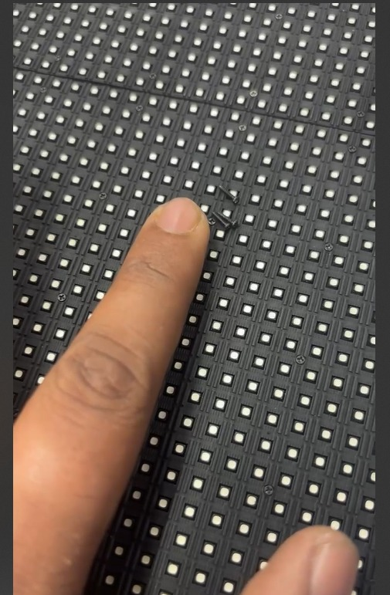

[*Video for Reference.mp4*](https://drive.google.com/file/d/1dqILX8j8XaAps2jnEO2ClbA-CurU9LIB/view?usp=sharing)

*Only Screwing and unscrewing needs to be automated. Removal of Meshes and frames will be done manually*